- Start a standard.exe and add following modules, classes.

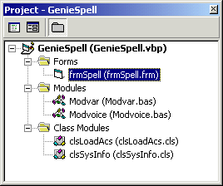
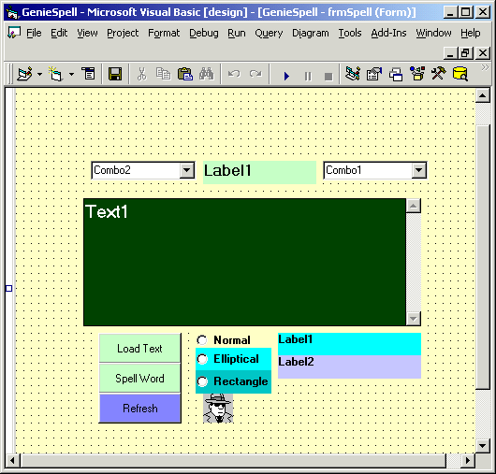

- Declare variable in Modules

' To load Genie
Public strchar As String '
Public strGeniePath As String
'To configure operating system
Public strOS9598 As Boolean
Public strOSNT20 As Boolean
'
Public Type SYSTEM_INFO
dwOemID As Long
dwPageSize As Long
lpMinimumApplicationAddress As Long
lpMaximumApplicationAddress As Long
dwActiveProcessorMask As Long
dwNumberOrfProcessors As Long
dwProcessorType As Long
dwAllocationGranularity As Long
dwReserved As Long
End Type

Public Declare Function GetVersionEx Lib "kernel32" Alias "GetVersionExA" (lpVersionInformation As OSVERSIONINFO) As Long

Public Type OSVERSIONINFO
dwOSVersionInfoSize As Long
dwMajorVersion As Long
dwMinorVersion As Long
dwBuildNumber As Long
dwPlatformId As Long
szCSDVersion As String * 128
End Type
Public Const VER_PLATFORM_WIN32_NT = 2

Public Const VER_PLATFORM_WIN32_WINDOWS = 1
Public strOS As String

- Code for classes

Class : clsLoadAcs

Option Explicit
' This code can be written as Private in a Form
'Since I have a plan to reuse this class, therefore I preffered to
'create clsLoadacs class.
Public Sub Load_genie()
If strOS9598 = True Then
strchar = "C:\WINDOWS\MSAGENT\CHARS\genie.acs"
ElseIf strOSNT20 = True Then
strchar = "C:\WINNT\MSAGENT\CHARS\genie.acs"
Else
MsgBox "genie is not loaded"
End If
End Sub

Class: clsOsinfo
Option Explicit
Public strOS As String
Public Sub OSSys_Type()
Dim typOS As OSVERSIONINFO
Dim lngword As Long

typOS.dwOSVersionInfoSize = 148
lngword = GetVersionEx(typOS)
If typOS.dwPlatformId = VER_PLATFORM_WIN32_WINDOWS Then
strOS9598 = True
strOS = " Windows 95/98/Me "
ElseIf typOS.dwPlatformId = VER_PLATFORM_WIN32_NT Then
strOS = " Windows NT/2000 "
strOSNT20 = True
End If
strOS = strOS & " Version" & typOS.dwMajorVersion & "/" & typOS.dwMinorVersion
End Sub

- Code for frmspell

Option Explicit

' Genie speaks
Dim strSpeakGenie As String
'
Private curAgent As IAgentCtlCharacter
'Get information about operating system
Dim osInfo As clsSysInfo
'Class loading Genie
Dim osLoadacs As clsLoadAcs
'Playing with Shape
'Setting windows' handle
Private Declare Function SetWindowRgn Lib "user32" (ByVal hwnd As Long, ByVal hRgn As Long, ByVal bRedraw As Boolean) As Long
Private Declare Function CreateRectRgn Lib "gdi32" (ByVal X1 As Long, ByVal Y1 As Long, ByVal X2 As Long, ByVal Y2 As Long) As Long
Private Declare Function CreateRoundRectRgn Lib "gdi32" (ByVal X1 As Long, ByVal Y1 As Long, ByVal X2 As Long, ByVal Y2 As Long, ByVal X3 As Long, ByVal Y3 As Long) As Long
Private Declare Function CreateEllipticRgn Lib "gdi32" (ByVal X1 As Long, ByVal Y1 As Long, ByVal X2 As Long, ByVal Y2 As Long) As Long
'
Private Sub cmdLoadText_Click()
On Error Resume Next
Dim x As String
Dim n As Variant
Dim Filename As String
Filename = App.Path & "\wordbook.txt"
Open Filename For Input As #1
'LOF for the length of the file
'x will hold all the characters
n = LOF(1)
x = Input(n, #1)
Close #1
Text1.Text = x
cmdspell.Enabled = True
End Sub

Private Sub cmdRefresh_Click()
Unload Me
frmSpell.Show
End Sub

Private Sub cmdspell_Click()
On Error Resume Next

Load_genie
Dim Search, Where ' Declare variables.
' Get search string from user.
Search = InputBox("Enter text to be found:")
Search = LCase(Search)
Mid(Search, 1, 1) = UCase(Mid(Search, 1, 1))
Where = InStr(Text1.Text, Search) ' Find string in text.
If Where Then ' If found,
Text1.SetFocus
Text1.SelStart = Where - 1 ' set selection start and

Text1.SelLength = Len(Search) ' set selection length.
strSpeakGenie = Text1.SelText
lblCorrect.Caption = strSpeakGenie
Call curAgent.Speak(strSpeakGenie)
cmbcorrect.AddItem strSpeakGenie
cmbcorrect.Text = cmbcorrect.List(0)
Text1.SelText = ""
CorrectWord
Else
Call curAgent.Speak("Oops I don't know this word. Please add in Wordbook.txt") ' Notify user.
cmbIncorrect.AddItem Search
cmbIncorrect.Text = cmbIncorrect.List(0)
InCorrectWord
End If
cmdLoadText.BackColor = vbRed
cmdLoadText.Caption = "X"
cmdLoadText.Enabled = False
cmdRefresh.Enabled = True
End Sub
Private Sub Load_genie()
On Error Resume Next
Dim strchar1 As String
Set osInfo = New clsSysInfo
Set osLoadacs = New clsLoadAcs
With osInfo
.OSSys_Type
frmSpell.Caption = .strOS
End With
osLoadacs.Load_genie
Call Agent1.Characters.Load("Genie", strchar)
Set curAgent = Agent1.Characters("Genie")
Call curAgent.Show
'bGenieshow = True
End Sub

Private Sub Form_Load()
cmdRefresh.Enabled = False
cmdspell.Enabled = False
End Sub

Private Sub optNormal_Click()
SetWindowRgn hwnd, CreateRectRgn(0, 0, 500, 500), True
End Sub
Private Sub optEllip_Click()
SetWindowRgn hwnd, CreateEllipticRgn(0, 0, 500, 450), True
End Sub

Private Sub optRndRect_Click()
SetWindowRgn hwnd, CreateRoundRectRgn(20, 20, 500, 500, 20, 20), True
End Sub

Private Sub InCorrectWord()
Static intDontKnow As Integer
intDontKnow = intDontKnow + 1
lblIncorrectscore.Caption = "InCorrect Or Not Known " & intDontKnow
End Sub
Private Sub CorrectWord()
Static intCorrect As Integer
intCorrect = intCorrect + 1
lblCorrectScore.Caption = "Correct Answer " & intCorrect
End Sub

- Run application:

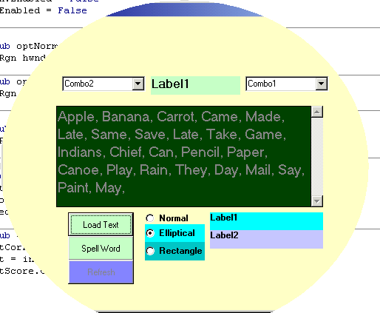
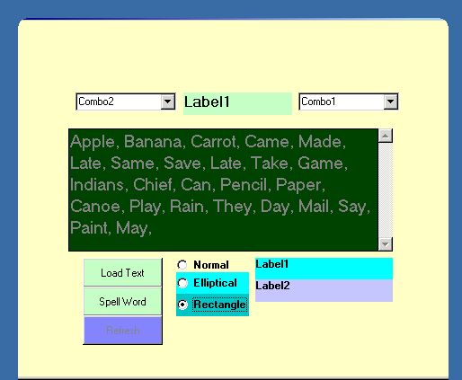

Now click on Load Text, type a word in the input box and note that word is removed form the display. Before hiding that word , the color will change
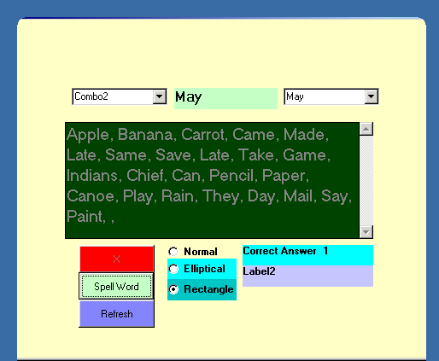
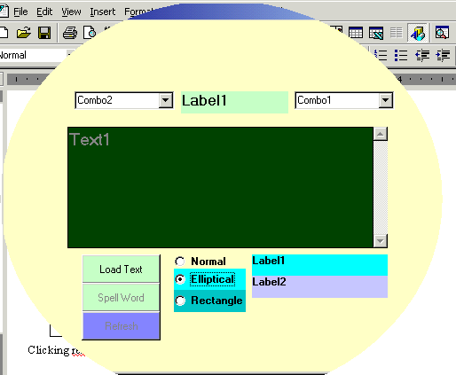

Clicking refersh will restore all the words loaded.

